Roll No. .................................
BA-333T: Quantitative Methods
Time Allowed: 3 Maximum Marks : 70
Note: Attempt two questions (out of 4) each from Section A & B carrying 12 marks each and the entire Section C consisting of 11 short answer type questions carrying 2 marks each.
SECTION–A
- i) Distinguish Between Relation and Function.
ii) Differentiate (2x +3) (3-4x)
iii) In a Class of 50 students there are 30 who play cards and 20 play carom, these are 10 students who play both games. Find the number of students who play.(a) cards only (b) carom only
- Differentiate (i) 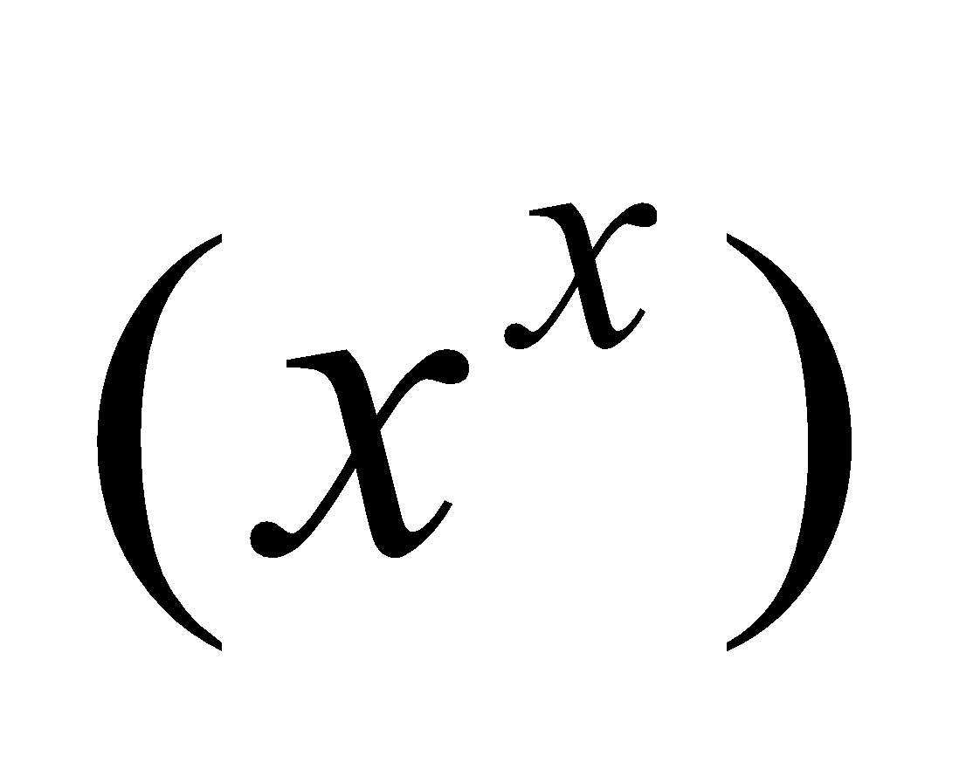 (ii) 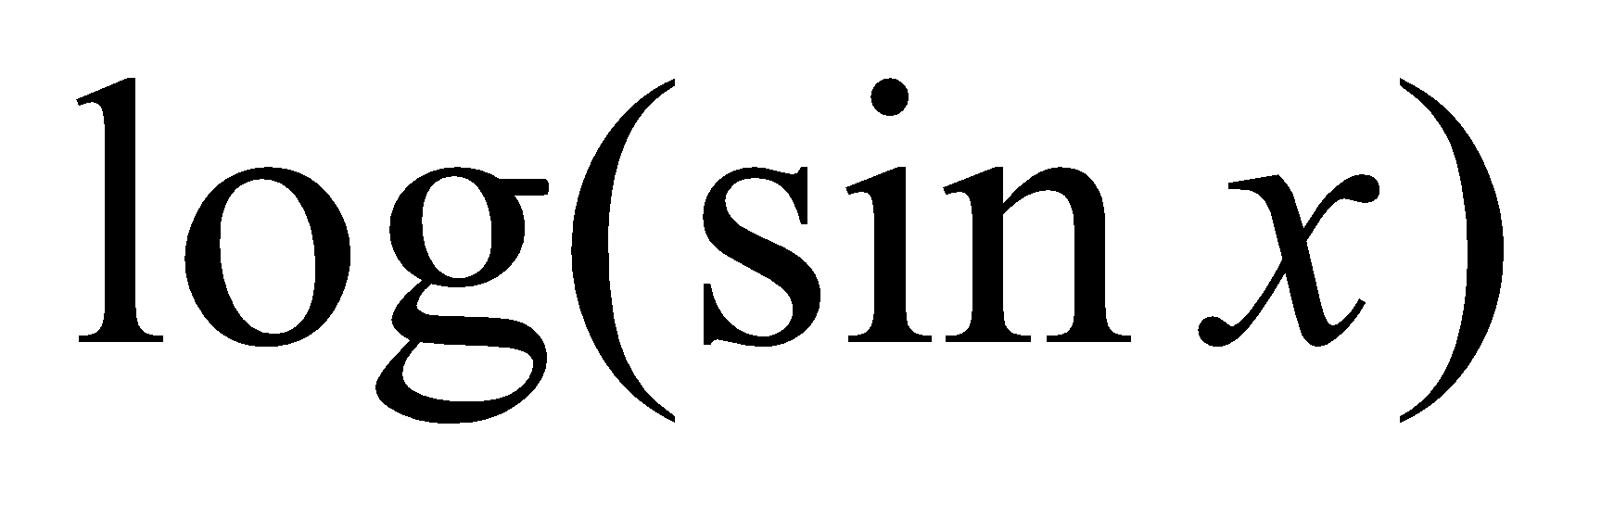

- Using the matrix inverse method, solve the following system of equations:
2x+y−z = 3, x+2y+z = 4, 3x−y+2z = 5.
- Calculate Mode of the following series:
Mid Value | 15 | 25 | 35 | 45 | 55 | 65 | 75 | 85
frequency | 5 | 8 | 12 | 16 | 28 | 15 | 3 | 2
(2 x 12 = 24)

SECTION–B
- Calculate Fisher's ideal index number from the following data and show that it satisfies the time reversal test and the factor reversal test.
Commodity | Base year |  | Current year
Commodity | Quantity | Price | Quantity | Price
A | 12 | 10 | 15 | 12
B | 15 | 7 | 20 | 5
C | 24 | 5 | 20 | 9
D | 5 | 16 | 5 | 14

- Find Spearman’s rank correlation coefficient for the following data:
X | 35 | 50 | 40 | 60 | 70
𝑌 | 42 | 68 | 54 | 75 | 80
- i) Differentiate between Correlation and Regression.
ii) Calculate regression equations of X on Y and Y on X of the following:

X: | 1 | 2 | 3 | 4 | 5
Y: | 2 | 5 | 3 | 8 | 7

- Fit a straight line to the given values ​​of X and Y. Also find the trend value.

X: | 1 | 2 | 3 | 4 | 5 | 6 | 7 | 8 | 9
Y: | 3 | 4 | 6 | 5 | 10 | 9 | 10 | 12 | 11

(2 x 12 = 24)

SECTION–C
9. Attempt all questions:
- Define Set.

- If , Show that x = f(y)

- Define Venn diagrams.
- Variance
- No Correlation
- Standard Deviation
- Scalar Matrix
- Why is the Fisher index called an ideal Index?
- Explain Rank Correlation
- Explain De- Morgan law with an example?
- Difference between Determinant and Matrix
(11 x 2 = 22)

